Executive Summary

Northwind Traders' sales data from 2021 to 2023 highlights key business dynamics shaping performance and opportunity. Repeat customers now generate the majority of revenue, underscoring strong loyalty but signaling a decline in new customer acquisition. Average Order Value (AOV) and purchase frequency show segmentation potential, revealing high-value but under-engaged customers. Beverages and Dairy products dominate the product mix, though profitability by category remains unclear due to missing cost data. Seasonal sales peaks in May–August offer clear planning advantages, while sales by category and region suggest tailored strategies for different markets. Together, these insights support strategic decisions in customer retention, product focus, and regional prioritization.

Overview Visualization: High-Level Sales Dashboard

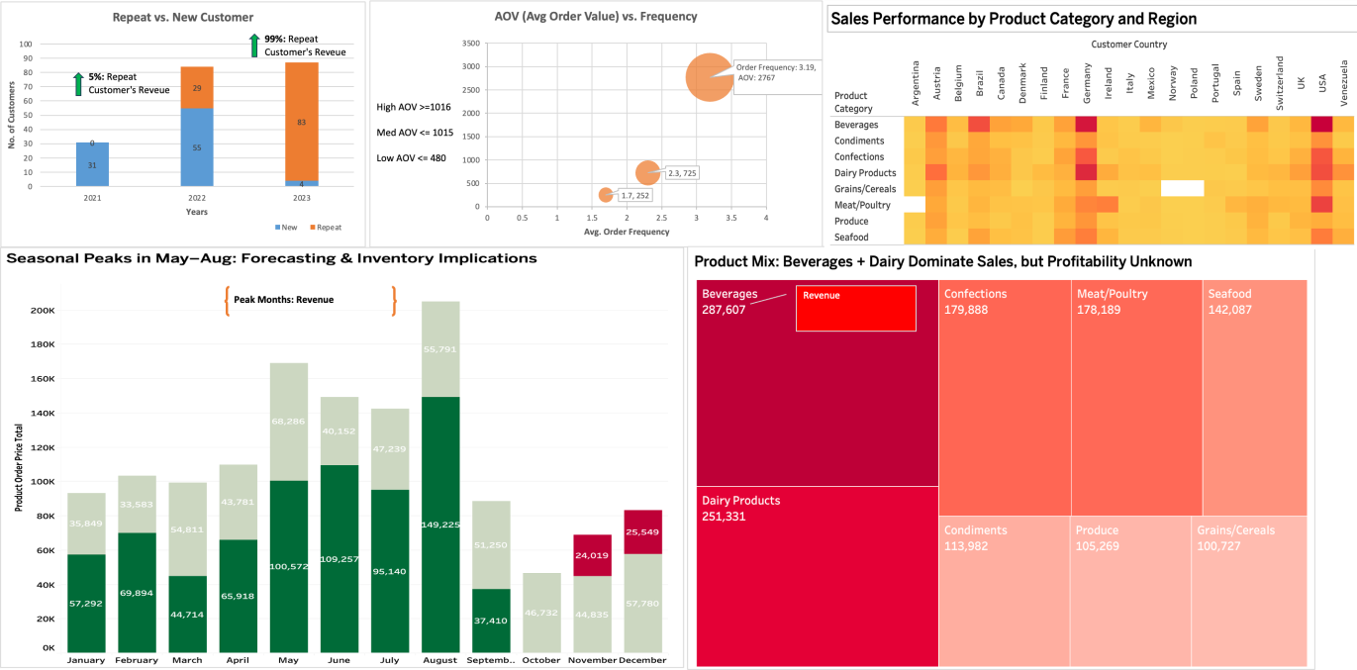

Deep Dive Analyses
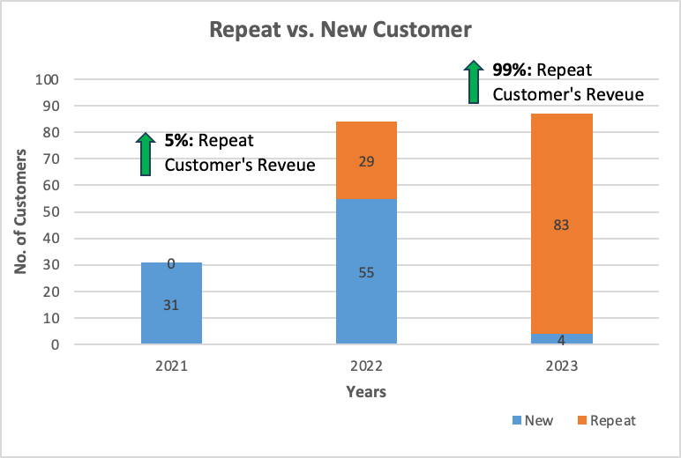

Repeat vs. New Customer Analysis

Why this data subset?
To distinguish between customer acquisition and retention trends, which impact both marketing and revenue strategy.

What story does the visual tell?
Repeat customers made up a growing share of revenue year-over-year, while new customer acquisition
declined steadily between 2021 and 2023.

What do we now know?
Customer loyalty is strong, but acquisition efforts are weakening, which could hinder future growth.

What don’t we know but need to know?
The reasons behind the drop in new customer acquisition are market saturation, reduced marketing
spend, or operational barriers

Average Order Value (AOV) vs. Frequency
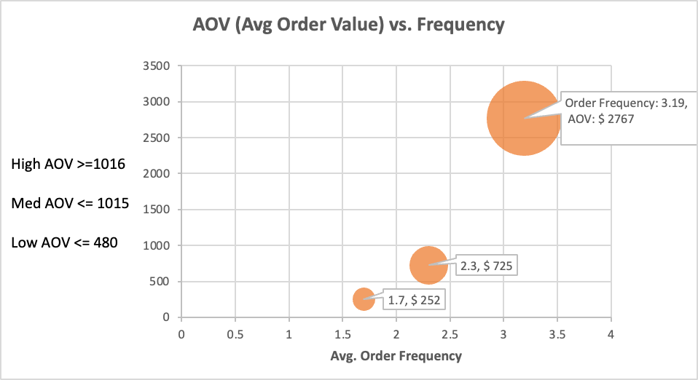

Why this data subset?
Identifies behavioral customer segments based on spending and engagement.
Supports targeted marketing, bundling, and operational resource allocation decisions.

What story does the visual tell?
High-AOV customers spend the most ($2,767) but purchase only ~3 times in 3 years; it could be more. High-AOV customers are 50% of the overall customer base.
Low-AOV customers order fewer and spend less (1.7, $252).
Medium-AOV customers show a balanced pattern of spend and frequency.

What do we now know?
High-AOV customers are prime candidates for engagement campaigns to boost order volume.

What don’t we know but need to know?
What motivates each segment (e.g., product type, discounts, urgency)? Are high-AOV customers loyal or price-sensitive occasional buyers?
What incentives or campaigns could increase frequency among high spenders?
How do customer satisfaction, acquisition cost, and lifetime value vary across segments?

- Product Mix – Beverages + Dairy Dominate

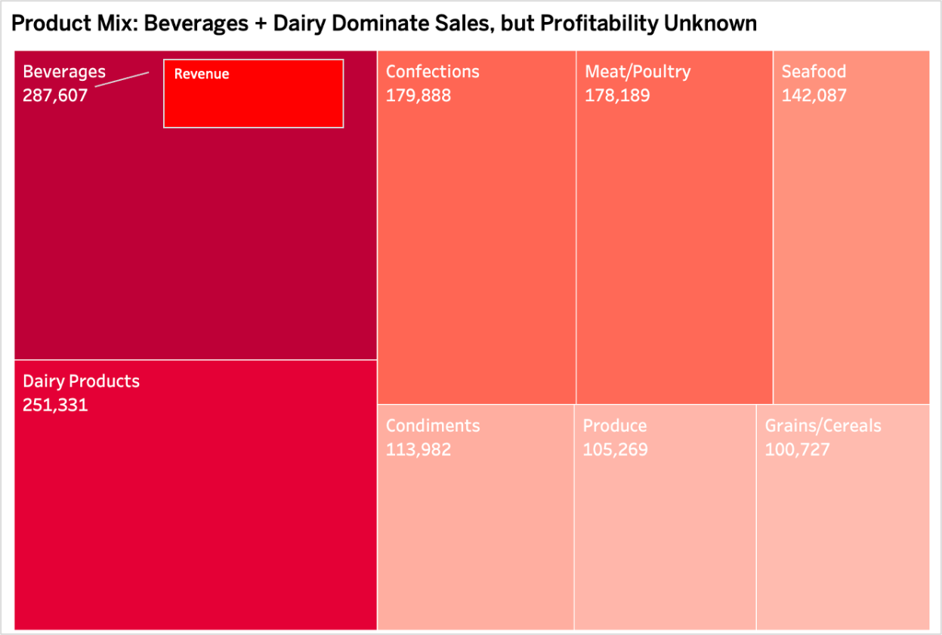

Why this data subset?
To understand what product categories contribute most to revenue and identify opportunities for optimization.

What story does the visual tell?
Beverages and Dairy consistently lead in total revenue, suggesting strong demand and volume sales across regions.

What do we now know?
Sales are concentrated in a few core categories, but without cost data, we can't assess their true
contribution to profitability.

What don’t we know but need to know?
Per-category profit margins, product-level return rates, or waste/spoilage rates that could drastically alter perceived value.

Seasonal Peak in May–August

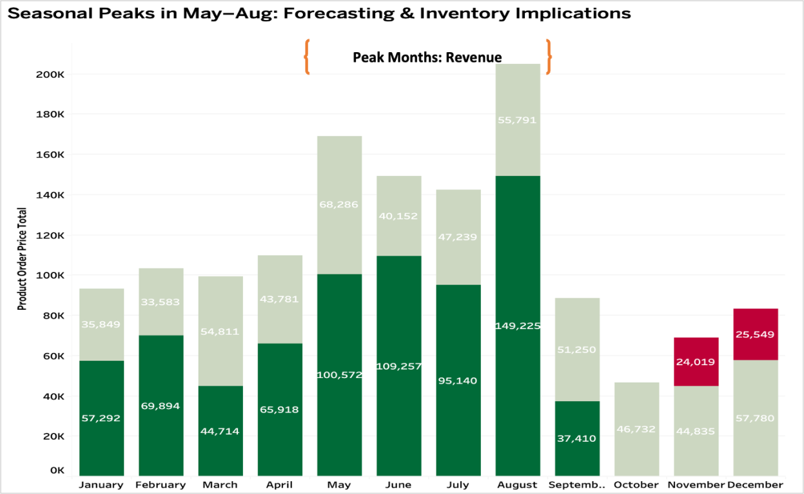

Why this data subset?
To support forecasting, inventory, and marketing planning by identifying high and low sales periods.

What story does the visual tell?
Sales consistently spike in the summer months, particularly May to August, and drop in October–November.

What do we now know?
There is predictable seasonality that should be leveraged for inventory buildup, promotional campaigns, and resource planning.

What don’t we know but need to know?
How seasonality differs across product categories or regions, and whether this trend is driven by internal
campaigns or external demand cycles.

Sales Performance by Category and Region

Why this data subset?
To discover how product performance varies by geography and identify region-specific strengths and gaps.

What story does the visual tell?
Certain categories dominate in some regions (e.g., Beverages in the U.S., Confections in Europe),
revealing clear regional preferences.

What do we now know?
Product success is not uniform — regional preferences should guide inventory, pricing, and promotional strategies.

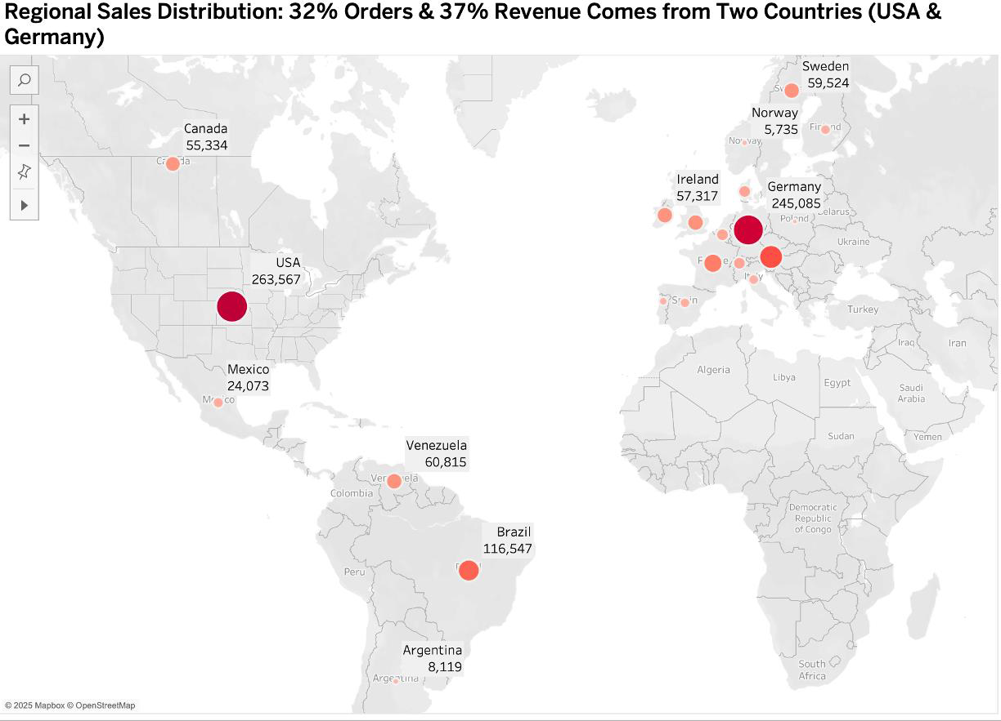

What don’t we know but need to know?
Whether these differences are due to consumer demand, supply chain efficiency, or sales strategy, and
how to optimize region-category alignment.

Conclusions

What is known
- Revenue growth is now being driven more by repeat customers than new ones.

- High-AOV customers are not being fully leveraged, while operational load may be heavy on low & mid-AOV buyers.

- Beverages and Dairy lead in volume, but profitability by category is unclear.

- Seasonal sales trends are consistent and actionable.

- Product performance varies by region, suggesting potential for localization.

What is unknown
- The profitability of top categories (cost/margin data missing)

- Why new customer acquisition is falling

- What drives regional product preferences

- Whether seasonal trends apply equally across product and market segments

Next Steps
  - Integrate Activity-Based Costing (ABC) to uncover product and customer-level profitability.

  - Investigate churn reasons and marketing funnel performance to revive acquisition.
  - Conduct regional analysis of inventory, promotions, and fulfillment strategies.
  - Expand the analysis to include category-level seasonal trends and customer engagement metrics.

Recommendations to SLT
    - Prioritize retention and enhance orders of high-AOV customers with loyalty and bundling strategies.

    - Reinvest in acquisition via digital and channel marketing to reverse declining new customer trends. 99% of 2023 revenue came from returning customers - a sign of strong loyalty. However, new customer acquisition dropped 93%, suggesting a weakening marketing funnel that needs high attention

    - Launch a pilot localization initiative — adjusting product focus and marketing based on regional sales behavior.

    - Implement ABC costing to better align decisions with profit, not just volume.

NORTHWIND TRADERS REQUEST FOR PROPOSAL (RFP)
Proposal Deadline: July 3, 2025
Contact: Aaron DiFrancia

Project Overview
Northwind Traders is a fast-growing international distributor of high-end foods and beverages, headquartered in the United States. Our client base includes grocery stores throughout the Americas and Europe. From 2021 to 2023, we experienced more than 15x growth in sales revenue, with market expansion and product strategy driving this acceleration.
The purpose of this RFP is to engage a qualified consulting or analytics firm to help us:
    - Understand our cost structure with more precision

    - Expand high-value markets and product lines

    - Streamline fulfillment and supply chains

    - Improve operational efficiency across the order lifecycle

    - Reverse recent declines in customer acquisition

Recent internal analysis identified several strategic growth levers:
    - Sales are highly concentrated in the USA and Germany

    - Beverages and Dairy dominate product revenue

    - A small group of customers account for the majority of sales

    - Sales volume peaks in summer months (May–August)

    - 99% of revenue in 2023 came from returning customers, while new customer acquisition fell sharply

Project Goals
    - Optimize Cost Structures
Implement Activity-Based Costing (ABC) to identify true costs per product, client, and transaction. Focus on high-volume categories like Beverages and Dairy to clarify margins.

    - Expand Profitable Markets & Products
Use regional data to guide market growth. Recommend a localization strategy that accounts for product-region fit (e.g., Beverages in the U.S. vs. Confections in Europe).
    - Streamline Distribution & Supply Chains
Align supply chain and distribution costs with seasonal sales patterns and region-specific behaviors to improve planning and efficiency.
    - Increase Order & Fulfillment Efficiency
Analyze order intake channels (fax, email, mobile, automated) and segment customers by Average Order Value (AOV) and frequency to optimize fulfillment workflows.
    - Revive Customer Acquisition
Analyze root causes of 93% acquisition decline including funnel drop-off rates, campaign performance, and external market factors.

Scope of Work
The selected firm will conduct a comprehensive, data-driven review. Expected deliverables include:
    - Activity-Based Costing model by product, customer, and region

    - Profitability analysis across all markets and product categories

    - Operational efficiency report covering shipping, order sizes, inventory cycles, and seasonal impacts

    - Customer segmentation by AOV and frequency

    - Churn and acquisition funnel analysis

    - Recommendations for order intake system improvements

    - Localization opportunity assessment by product and region

    - Develop targeted engagement strategies for high-AOV customer segments to increase order frequency and lifetime value.
All deliverables should be visualized clearly and translated into actionable recommendations.

Current Roadblocks & Barriers
This project will require coordination across multiple departments. Legacy systems (e.g., fax/email-based ordering) may limit automation options in the short term. Additionally, operational updates must be introduced in ways that minimize disruption to business continuity.

Evaluation Metrics & Success Criteria
Proposals will be evaluated based on:
    - Quality and clarity of insights

    - Ability to identify cost-saving opportunities

    - Strength of data storytelling and visual communication

    - Project management approach and timeline

    - Relevant experience, especially in food and beverage distribution

Project success will be measured by cost savings, efficiency improvements, and the actionability of delivered insights.

Submission Process
Firms must submit a proposal that includes:
    - Overview of relevant experience
    - Description of proposed methodology and tools
    - Key team members and qualifications
    - Timeline and cost structure

Please submit your proposal electronically by July 3, 2025, to:
📧 procurement@northwindtraders.com

POTENTIAL RECIPIENTS
This RFP may be shared with select firms that specialize in supply chain analytics, margin optimization, and operational transformation in the food and beverage industry. Potential recipients include:
    - Accenture – Known for global supply chain consulting and ABC modeling.
    - McKinsey & Company – Experienced in retail analytics, profitability, and logistics.
    - Deloitte Consulting – Experts in process transformation and digital optimization in CPG and food distribution.

